Overflow Contractor Lot Directions

$14 Dollars a day/ Per entry

Step 1)

When entering on Airport Service Rd, stay to the left (lower ramp) **towards arrivals.**  When you approach the fork in the road, stay to the left and enter the garage.

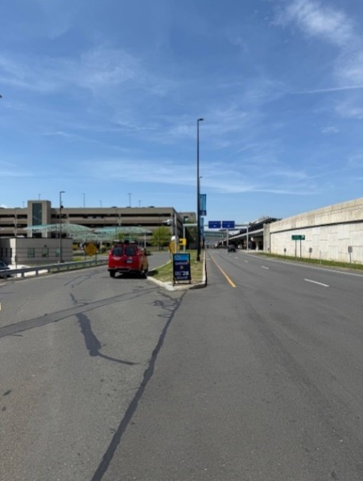

Step 2)

Enter into "garage parking" and take a ticket. (This ticket will be needed to enter the overflow lot, keep handy)

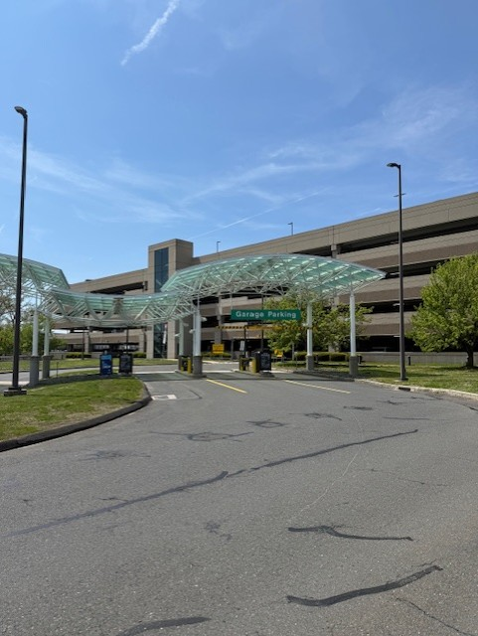

Step 3)

Once you enter the Garage, make a left into the garage and take a quick right at the "additional parking" sign. (Approximately 10 feet from where you enter) You will need to exit this garage and keep going into the next garage where additional parking is located. Keep driving straight through the **entire garage** until you approach the overflow lot labeled "contractor parking only".

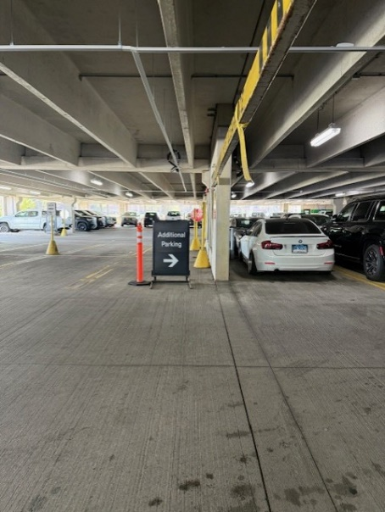

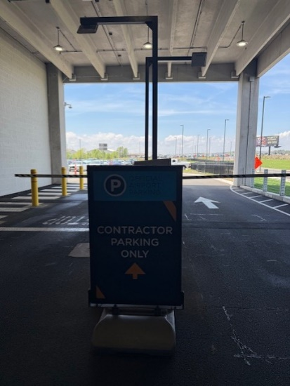

Step 4)

At the "contractor parking only" sign, take the previously pulled ticket and insert the ticket into this machine, it will recode the ticket for $14. (Do not lose this ticket, you will need it to get out of the contractor lot).

Step 5)

Once you set to leave, please reinsert your ticket at the first exit gate. Take a right out of the first exit gate to see the cashier/pay for the parking at the next gate.

